***SQL ASSIGNMENT-1***

**Ques-1** For different category of acquirers, what is the average number of months since the inception of the acquired company after which they are acquired.

**Query-**

SELECT COALESCE(a.acquirer_category_code,'other') AS acquirer_category_code,

ROUND(AVG((a.acquired_at_cleaned :: date - c.founded_at_clean:: date)/(365.25/12)),2) AS avg_no_of_months

FROM tutorial.crunchbase_companies_clean_date c

JOIN tutorial.crunchbase_acquisitions_clean_date a

ON c.permalink = a.company_permalink

WHERE c.founded_at_clean IS NOT NULL

GROUP BY 1

Result-

**Ques-2** Is there any trend for quarters when more companies are acquired.

**Query-**

SELECT

CASE

WHEN extract(month FROM acquired_at_cleaned) <=3 THEN 'Q1'

WHEN extract(month FROM acquired_at_cleaned) <=6 THEN 'Q2'

WHEN extract(month FROM acquired_at_cleaned) <=9 THEN 'Q3'

ELSE 'Q4'

END as quarter,

COUNT(*) AS no_of_companies_acquired

FROM tutorial.crunchbase_acquisitions_clean_date

GROUP BY 1

ORDER BY 2 DESC;

**Ques-3** For each company_category_code identify the average raised_amount_usd per quarter?

**Query-**

SELECT COALESCE(category_code,'other') AS company_category_code ,

CASE

WHEN extract(month FROM founded_at_clean :: date) <=3 THEN 'Q1'

WHEN extract(month FROM founded_at_clean :: date) <=6 THEN 'Q2'

WHEN extract(month FROM founded_at_clean :: date) <=9 THEN 'Q3'

ELSE 'Q4'

END as quarter,

ROUND(AVG(funding_total_usd)::numeric, 2) AS average_raised_amount_usd

FROM tutorial.crunchbase_companies_clean_date

WHERE funding_total_usd IS NOT NULL AND

founded_at_clean IS NOT NULL

GROUP BY 1,2

ORDER BY 1,2

**Result**

**Ques-4** Which investor (company ) is more likely to invest in USA based companies?

**Query-**

select investor_name , count(*)

from tutorial.crunchbase_investments

where company_country_code = 'USA'

group by 1

order by count(*) desc

LIMIT 1;

**Ques-5** For different type of funding rounds, what is the average raised amount per quarter.

**Query-**

SELECT funding_rounds,

CASE

WHEN extract(month FROM to_date(founded_at_clean,'yyyy-mm-dd')) <=3 THEN 'Q1'

WHEN extract(month FROM to_date(founded_at_clean,'yyyy-mm-dd')) <=6 THEN 'Q2'

WHEN extract(month FROM to_date(founded_at_clean,'yyyy-mm-dd')) <=9 THEN 'Q3'

ELSE 'Q4'

END as quarter,

ROUND(AVG(funding_total_usd)::numeric,2) as avg_raised_amount

FROM tutorial.crunchbase_companies_clean_date

WHERE founded_at_clean IS NOT NULL

GROUP BY 1,2

ORDER BY 1,2

**Result**

**Ques-6** Identify companies that received an investment from Japan following an investment from Great Britain where investor is finance category company.

**Query-**

SELECT a.company_name

FROM (

SELECT company_name, investor_country_code,

lag(investor_country_code) OVER( order by funded_at :: date ASC) AS prev_investor_country

from tutorial.crunchbase_investments

where investor_category_code = 'finance') a

WHERE a.investor_country_code = 'GBR' AND a.prev_investor_country = 'JPN'

**Result-**

**Ques-7** Out of all 'operating' status companies, which category of companies have the highest average funding_total_usd?

**Query-**

SELECT COALESCE(category_code, 'other') as category_code,

ROUND(AVG(funding_total_usd) :: numeric , 2) as avg_funding_total_usd

FROM tutorial.crunchbase_companies_clean_date

WHERE status = 'operating'

GROUP BY 1

ORDER BY 2 DESC

LIMIT 1

**Result-**

**Ques-8** For each category, what percent of companies received funding within 3 years of their founding?

**Query –**

SELECT COALESCE(category_code, 'other') AS com_category,

SUM(CASE WHEN ABS(first_funding_at::date - founded_at ::date)<=365*3 THEN 1 ELSE 0 END)::numeric/count(*)*100 perc_companies

FROM tutorial.crunchbase_companies

GROUP BY 1

ORDER BY 2 DESC

**Result –**

**Ques-9** Clean the 'last_funding_at' column (convert it to time stamp) and get the time difference with the current time.

**Query –**

SELECT AGE(NOW(), last_funding_at::date) AS days_since_last_funding

FROM tutorial.crunchbase_companies

WHERE last_funding_at IS NOT NULL;

**Result –**

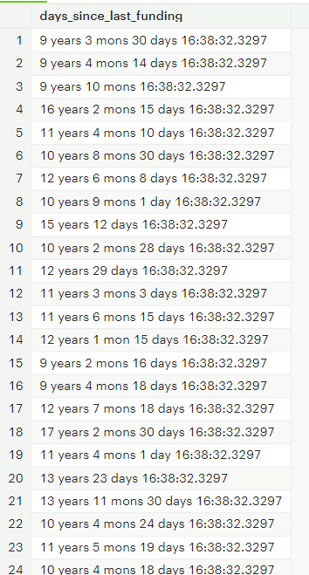

**Ques-10** list of company got closed after getting funding since one year of inception

**Query-**

select name

from tutorial.crunchbase_companies

where status = 'closed' AND founded_at IS NOT NULL AND (abs((first_funding_at :: date - founded_at :: date))/365.25) <=1

**Result-**

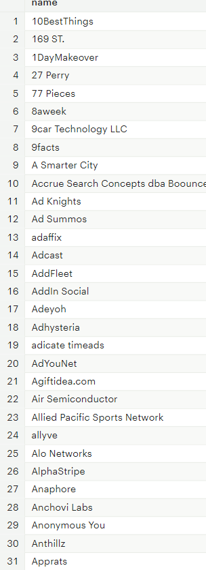

**Ques- 11** Different status count in different category of the companies.

**Query**

SELECT COALESCE(category_code, 'other') AS category_code,

COALESCE(SUM(CASE WHEN status = 'acquired' THEN 1 END),0) acquired_count,

COALESCE(SUM(CASE WHEN status = 'ipo' THEN 1 END),0) ipo_count,

COALESCE(SUM(CASE WHEN status = 'operating' THEN 1 END),0) operating_count,

COALESCE(SUM(CASE WHEN status = 'closed' THEN 1 END),0) closed_count

FROM tutorial.crunchbase_companies

GROUP BY 1

ORDER BY 1

**Result –**

